# CS 255 System Design Document

## UML Diagrams

### UML Use Case Diagram

This diagram illustrates the key interactions between users and the DriverPass system. It includes primary actors such as Driver, Instructor, Administrator, and System, and use cases such as Register Driver, Request Driver Pass, Validate Driver Credentials, Generate Pass, and Report Issue.

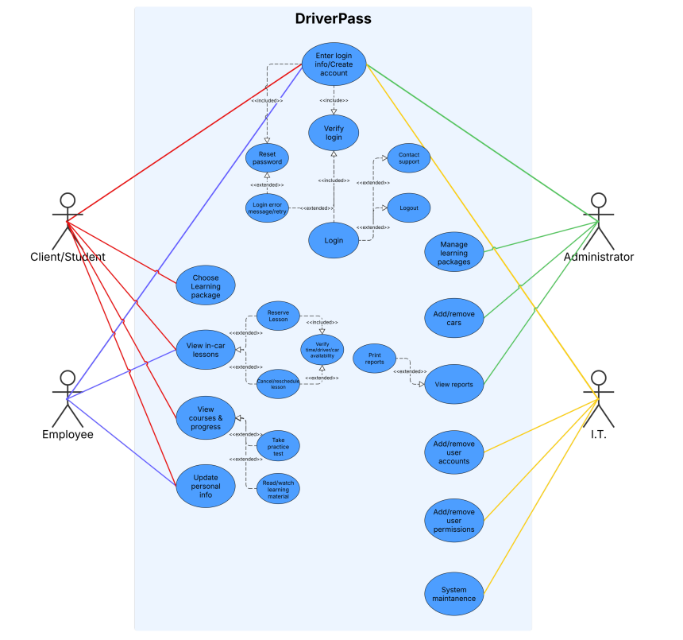

### UML Activity Diagrams

*Activity Diagram 1: Schedule a Driving Lesson*

This diagram illustrates how a student interacts with the system to schedule a driving lesson, including login, selecting a time, conflict checking, and receiving confirmation.

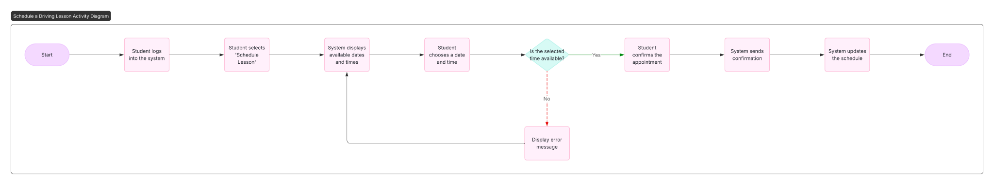

*Activity Diagram 2: Register Driver*

This diagram outlines the process a user follows to register as a new driver, showing data entry, identity verification with potential error handling, submission, and confirmation notification.

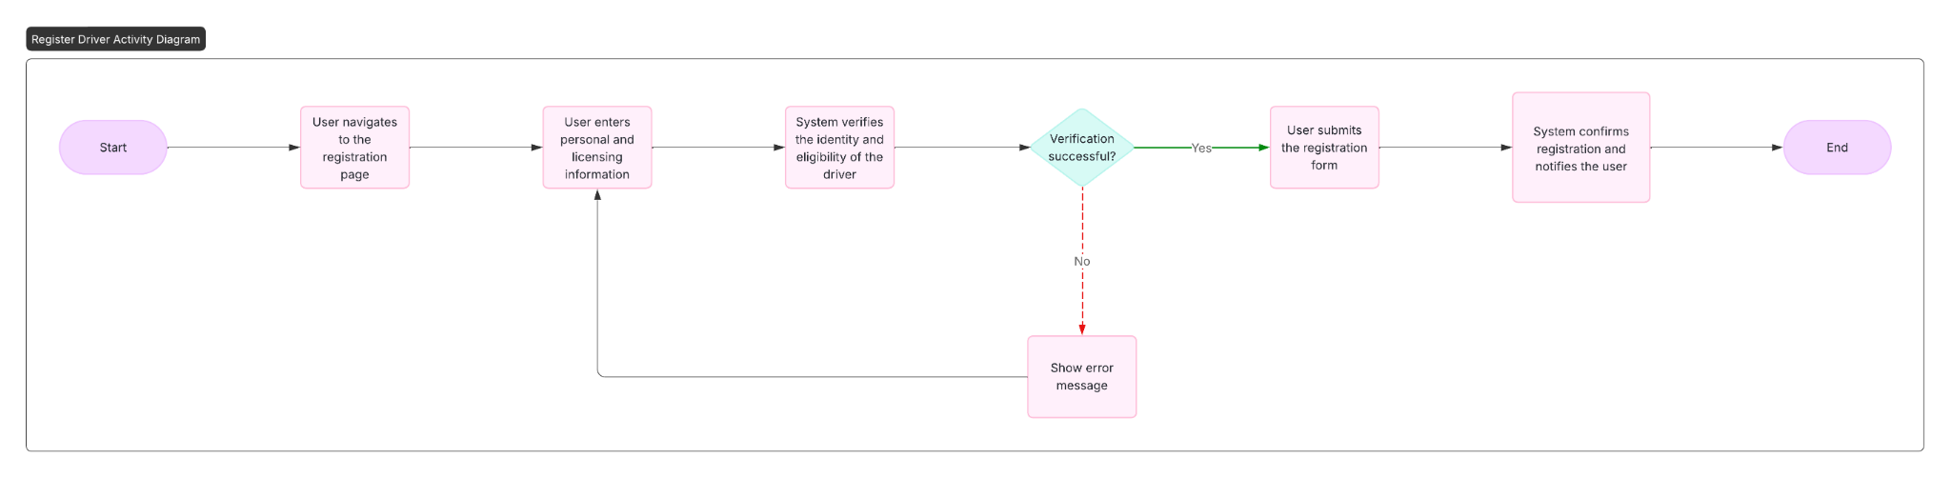

### UML Sequence Diagram

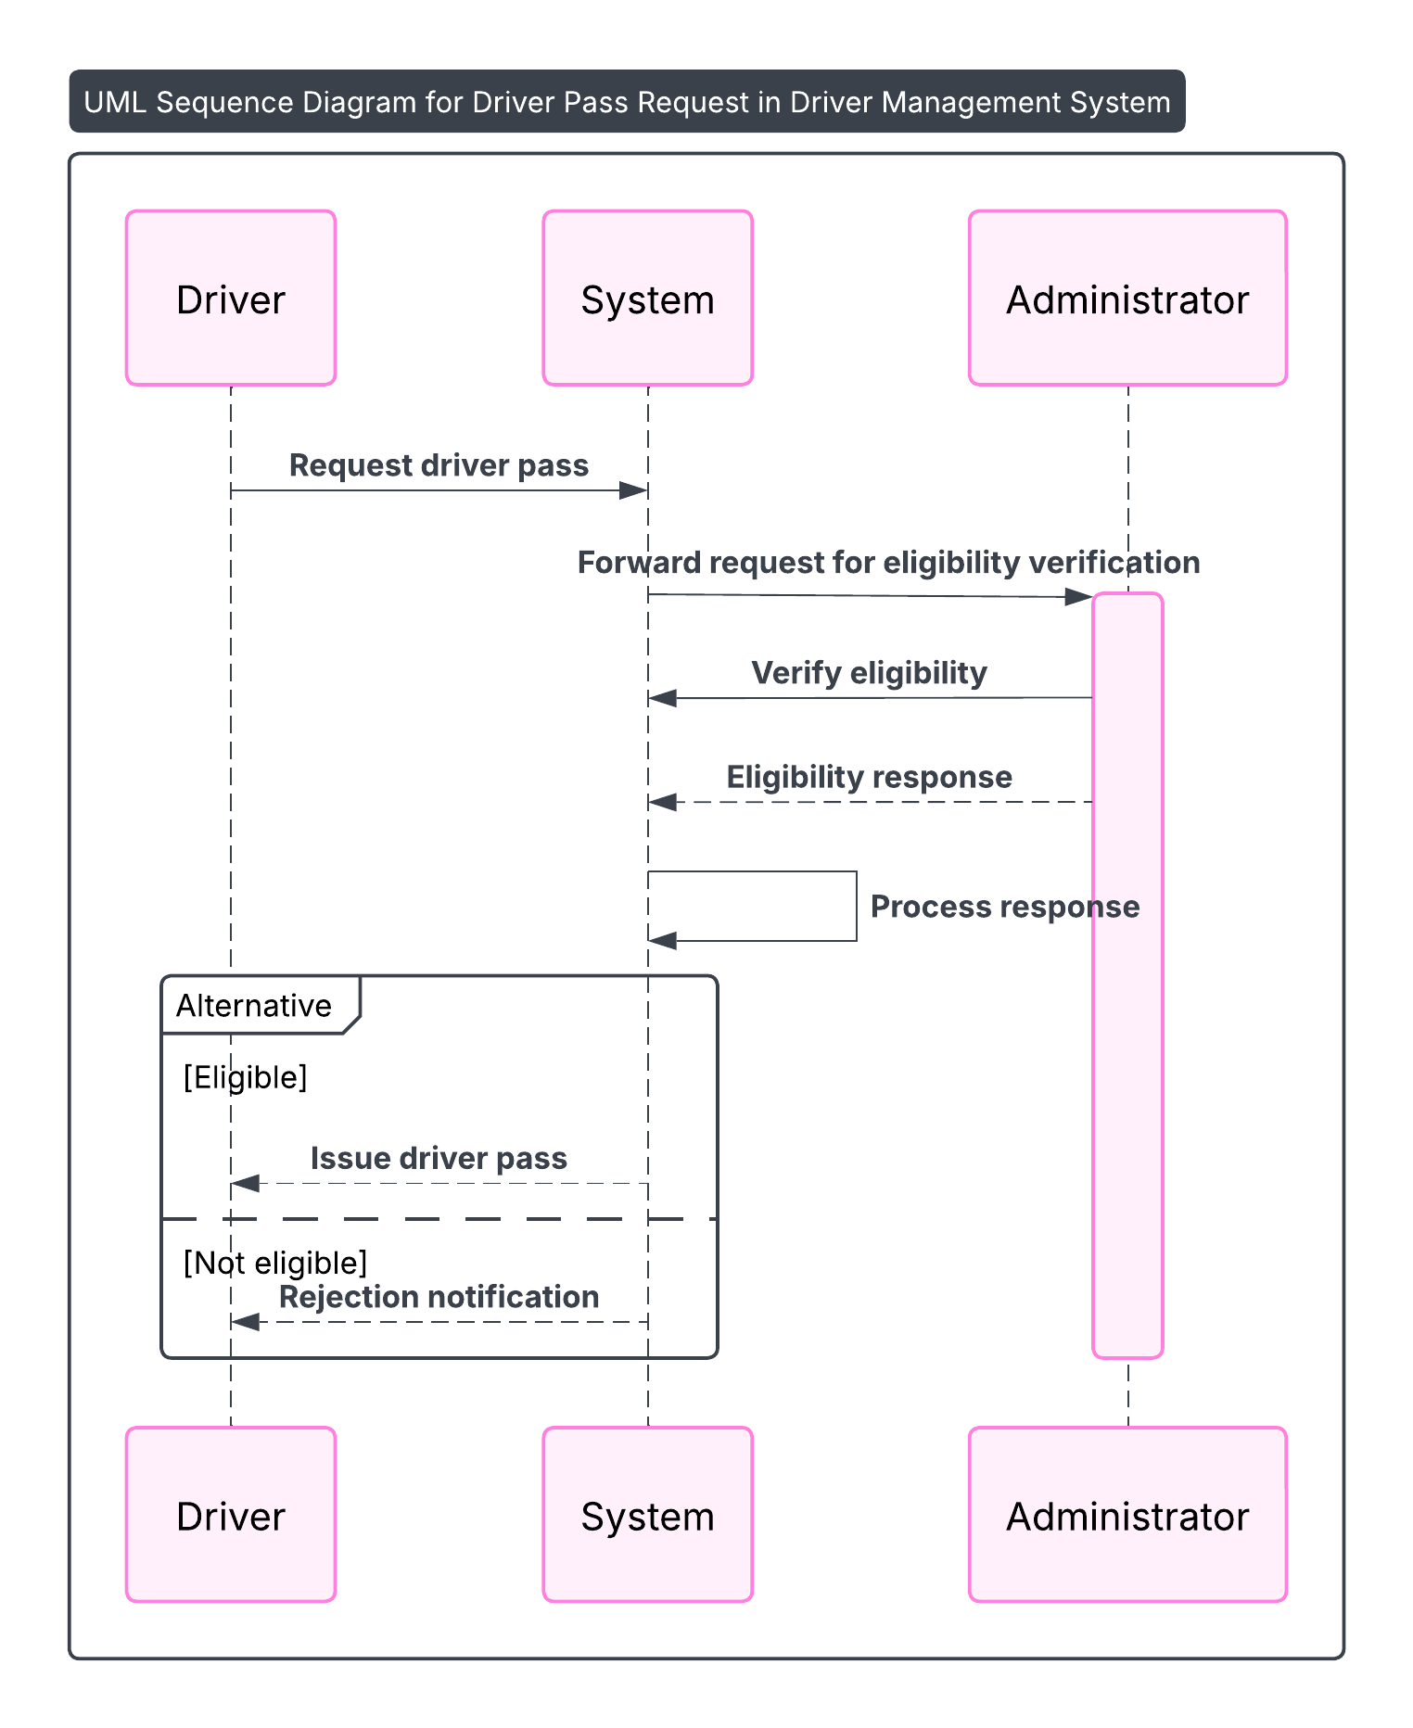

### UML Class Diagram

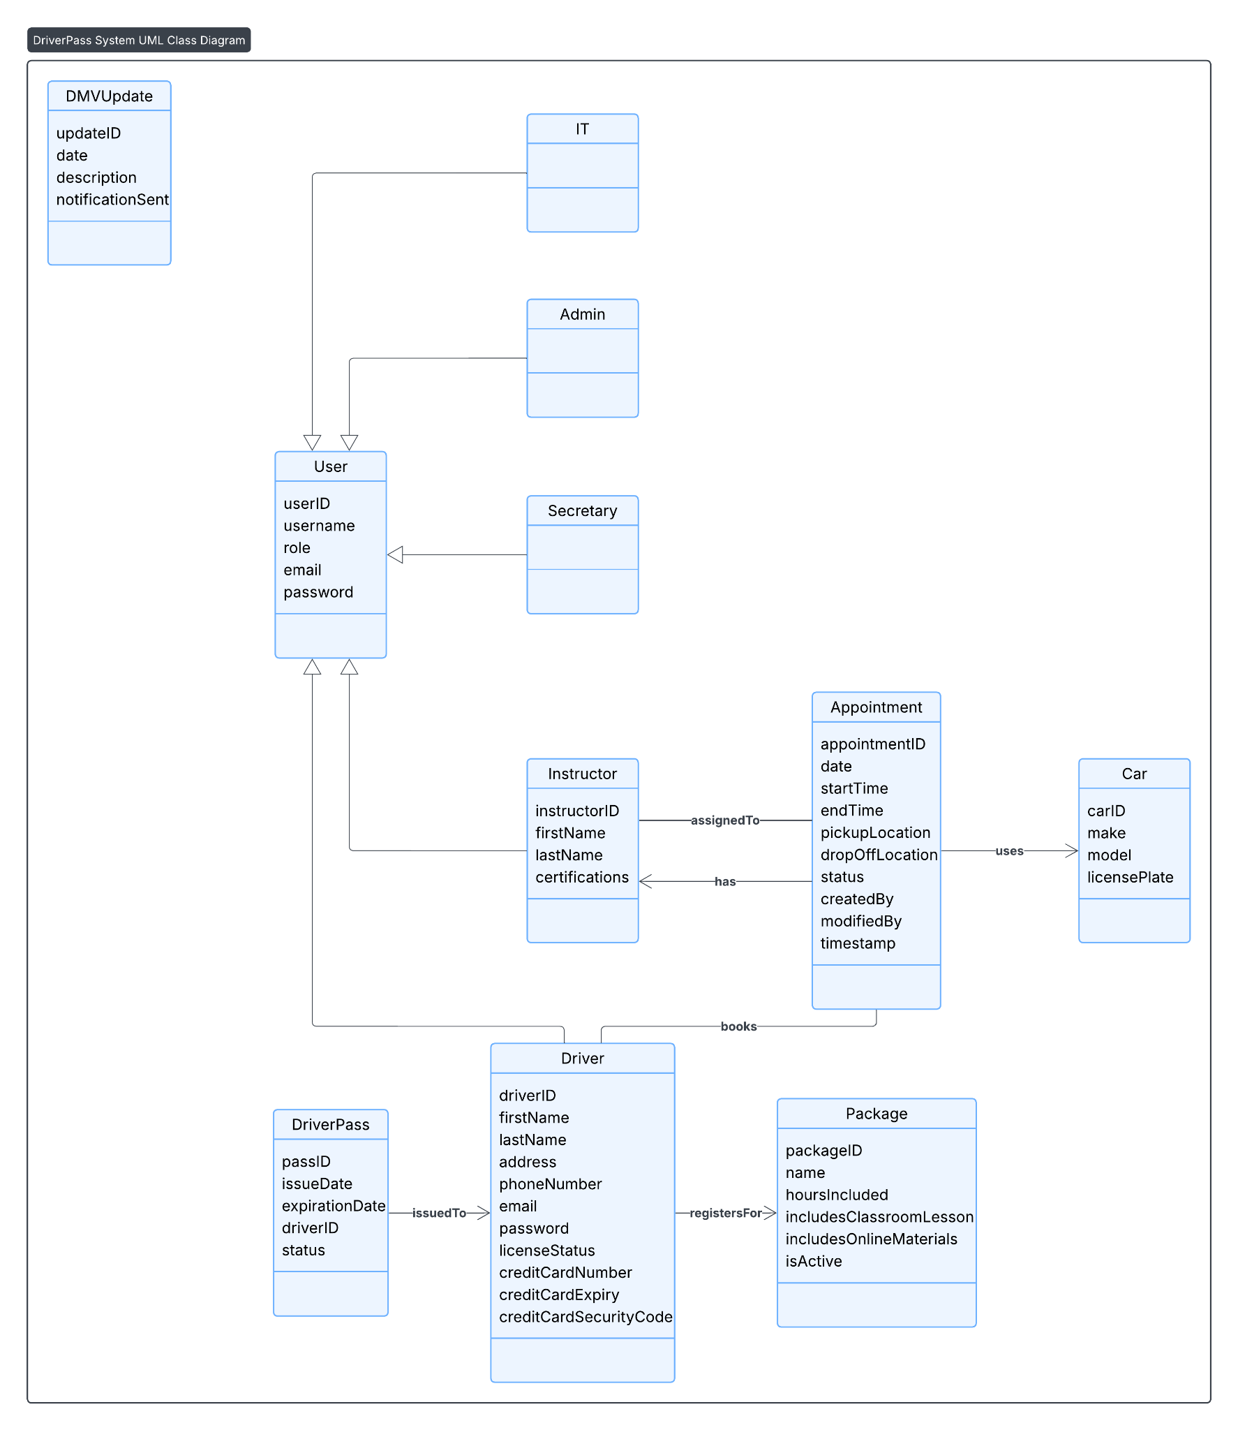

## Technical Requirements

Based on the UML diagrams and system design, the following technical requirements are necessary:

* ***Hardware:***
  + *Web server capable of handling simultaneous user requests securely.*
  + *Database server for storing driver, pass, and administrative data with backup capabilities.*
* ***Software:***
  + *Web application framework (e.g., React for front-end, Node.js or Django for backend).*
  + *Relational database management system (e.g., PostgreSQL or MySQL).*
  + *Security tools for user authentication and data encryption.*
* ***Tools and Infrastructure:***
  + *Cloud hosting platform (e.g., AWS, Azure, or Google Cloud) to ensure scalability and availability.*
  + *Secure SSL/TLS certificates for encrypted data transmission.*
  + *Backup and disaster recovery tools to prevent data loss.*
  + *Logging and monitoring tools to track system health and usage.*
* ***Other considerations:***
  + *The system must support concurrent users and ensure data consistency.*
  + *User-friendly interface accessible on desktop and mobile devices.*
  + *Compliance with privacy laws to protect driver information.*